**Energy and Life**

**Note Taking Guide**

1. **Energy** is __________________________________________________
2. Organisms can be classified by how they get their energy
   1. Autotrophic -
      1. Examples:
   2. Heterotrophic -
      1. Examples:
3. Forms of energy (list 4)

Adenosine Triphosphate **ATP**

* 1. **Function**: Cells use ATP to ___________ and _____________ energy.
  2. Cellular “currency” C:\Documents and Settings\duncansta\Local Settings\Temporary Internet Files\Content.IE5\6UG0X62W\MC900015818[1].wmf
  3. **Structure**:

C:\Documents and Settings\duncansta\Local Settings\Temporary Internet Files\Content.IE5\9CU452GE\MC900364292[1].wmf

1. Adenosine Diphosphate **ADP**
   1. **Structure:**

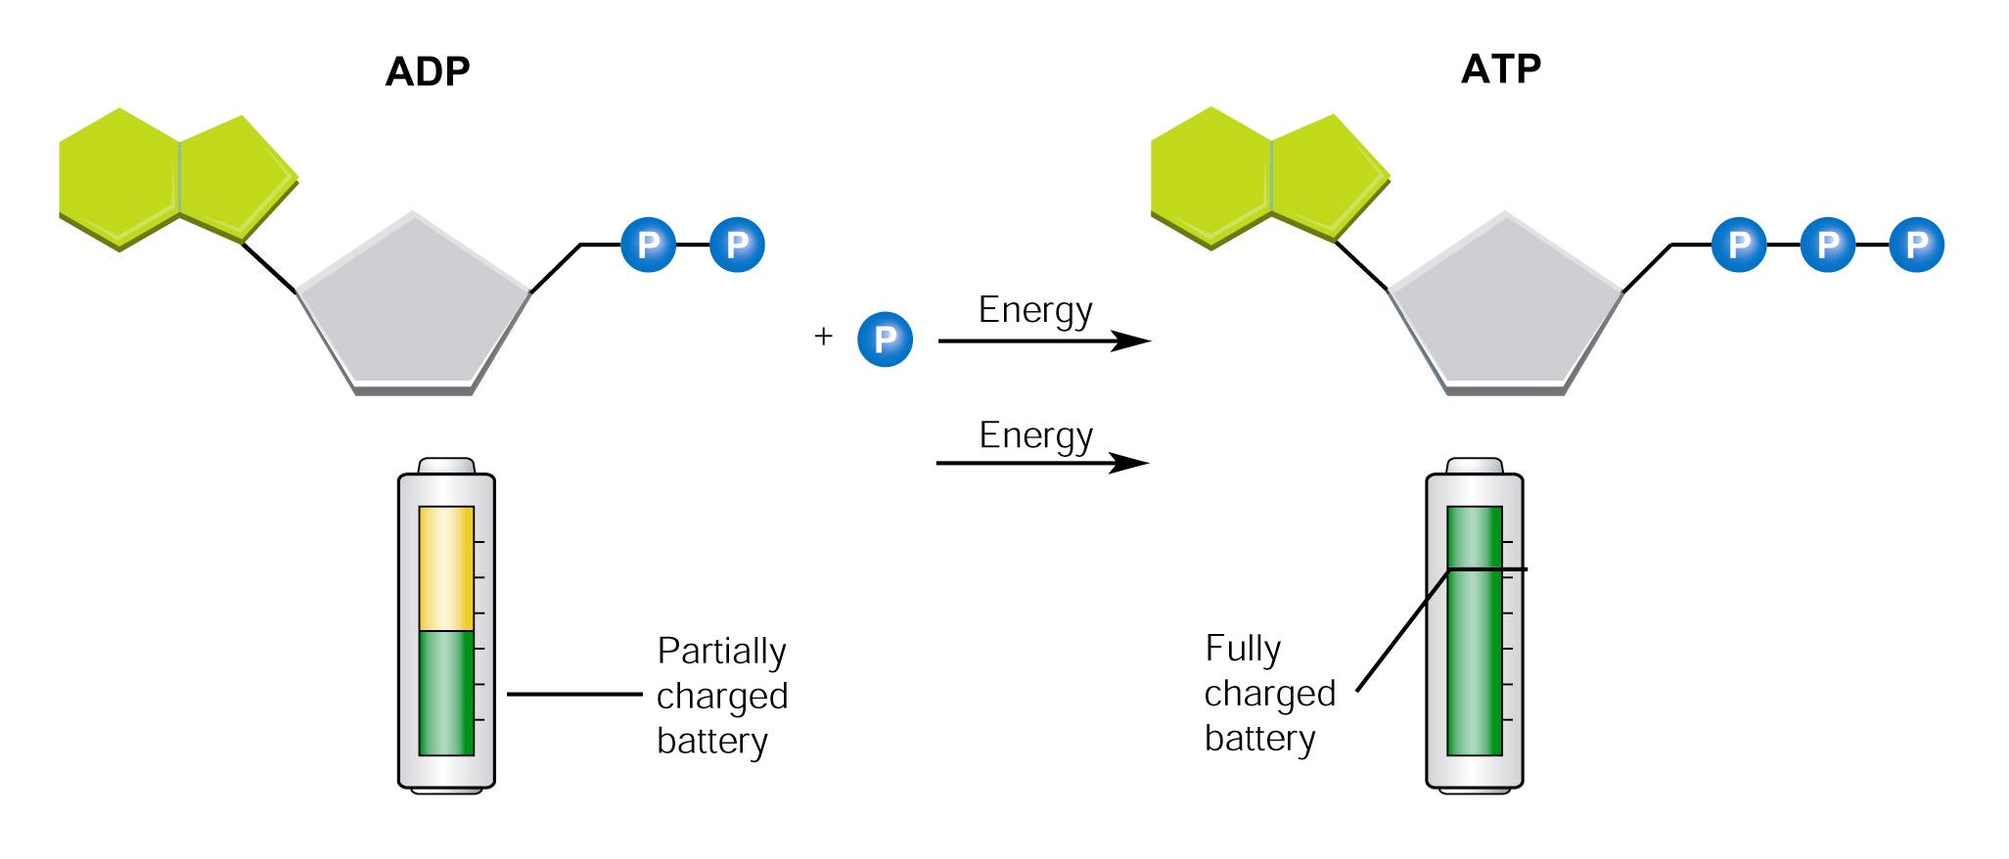

1. How is energy released?
2. Using Biochemical Energy
   1. Cells only have a ____________ of ATP on hand, because