Name:_____________________________________________________________________ Per: ______
Mitosis Web Quest
In this internet lesson, you will review the steps of mitosis using step by step animation of cell division. You then view an onion root tip and calculate the percentage of cells at each of the stages of cell division.

Mitosis Tutorial
http://www.cellsalive.com/mitosis.htm (go to the HW web site)
**On the left side of the screen is a navigation bar, click on the link to “MITOSIS”. Read the text below the step by step animation on this page and also view the animation (hit play) and/or you can slow down the video by clicking step by step through the phases.
1. List the stages of mitosis (Notice – there’s an extra phase here…”prometaphase” – sometimes that is added as an “in-between” phase between prophase and metaphase. In my class you are only responsible for knowing PMAT)
2. In which stage does each of the following occur:
Chromatin condenses into chromosomes | _____________________________________________
Chromosomes align in center of cell. | _____________________________________________
Longest part of the cell cycle. | _____________________________________________
Nuclear envelope breaks down. | _____________________________________________
Cell is cleaved into two new  daughter cells. | _____________________________________________
Daughter chromosomes arrive at the poles. | _____________________________________________

Watch the video carefully.
3. The colored chromosomes represent chromatids.
--Why are there two chromatids of each color (what must have happened to each chromosome prior to mitosis)?

--In this animation, each pair of sister chromatids is a different color (so there are 4 different colors). How many colors should there be to make this drawing more accurate? WHY?

--How many chromosomes are visible at the beginning of mitosis? _______
-- How many are in each daughter cell at the end of mitosis? _________
--What are the little green T shaped things in the cell? ________________

-- What happens to the centrioles during mitosis?

4. Identify the stages of these cells:
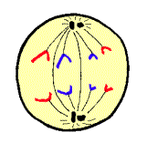 | 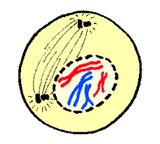 | 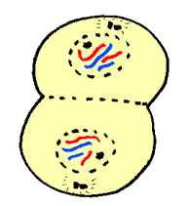 | 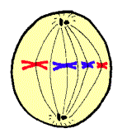

____________ _______________ _______________ _______________

**Onion Root Tip - Online Activity http://www.biology.arizona.edu/cell_bio/activities/cell_cycle/cell_cycle.html (go to the HW web site)

*Read the introduction, then click the “next” button.

*Check out the different phases & read them & hit “next”.

*Read the “assignment” then hit “next”

*You will have 36 cells to classify. When you're finished, record your data in the chart below.
 | Interphase | Prophase | Metaphase | Anaphase | Telophase | Total
Number of cells |  |  |  |  |  | 36
Percent of cells |  |  |  |  |  | 100%
http://www.stowe.k12.vt.us/sms/teachers/jgrogan/mitosiswebquest.htm

Q: What do you notice about the stages from your calculations in the table?

Q: What did you notice about the difference between Interphase & Prophase?

