Cornell note taking is an efficient method for mastering information, not just recording facts. Each step prepares the way for the next part of the learning process. It is based in brain research that outlines the following:
- Not writing notes in class = Students forgot 60% of information
- Do write notes in class = Students retained 60% of information
- Reviewing notes = Students retained 90-100% of information

How should notes be recorded?

During class = record notes on the right-hand side of the page:
- Write main ideas down with details that are meaningful to concepts
- Don’t force outline systems, but do use any obvious numbering
- Use abbreviation to save time
- Use graphic organizers or pictures to help
- Separate blocks of information logically
At end of class or after class refine notes:
- Read your notes and underline key words and phrases
- Correct/enhance incomplete items
- Write questions in the left-hand column about the information on the right.
- Read underlined words and write recall cues in the left-hand column
- At bottom of the page, write a summary paragraph about your notes
How to set up your paper
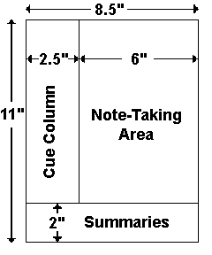

Topic:

Name:
Date:
Period:
Biology 1

Summary:

